Contact person for editorial offices:
Dirk Rott, Head of Marketing

July 5th, 2019

Press release WA1904: Speed measurement

Images and text are approved for publication in the press (print and online). Please send us a specimen copy after publication. Thank you for your efforts in advance.
________________________________________________________________________
Inline speed measurement with PROFINET or EtherCat
During the production or printing of foils, carpets, PVC floors, textiles, paper or long logs, on storage and retrieval machines or when transporting bulk goods or parcels, it is often necessary to measure the speed inline so that the pressure is correct, the length or the volume fits or positions of identified errors can be found.
A few years ago, Wachendorff Automation developed the LMS length measurement system with incremental pulses for this application. It is robust, with the choice of different surfaces of the measuring wheels suitable for almost all materials, the sensor is closed and there is a large selection of outputs with which the LMS can be connected to all commercially available controls or drives. For optimum adhesion, the contact pressure can be set step-by-step with a defined raster by simply using a single screw. Mounting is flexible in all imaginable situations and proven a thousand times.
Most recently, Wachendorff now offers a length measurement system LMS with a PROFINET or EtherCat interface. The robust bearing packages are designed exactly as the incremental "colleagues" and therefore sufficiently robust for this type of application. Also the dimensions (especially a low depth and a reasonable cable outlet) and the other parameters such as shock and vibration have been taken into account during the development.
The robust and compact WDGA 58B absolute encoders with EnDra (multiturn) and QuattroMag (singleturn) magnetic technology, which form a unit together with the linear encoder, can be connected directly to any PLC or drive via PROFINET or EtherCat.
This is very space-saving and also reduces costs in the control cabinet. The customer can save on the incremental input module in the PLC and gain space for more functions or smaller dimensions.
Integration in the TIA portal or in TwinCat and in a design program is also very simple. Wachendorff provides STEP files and sample programs.

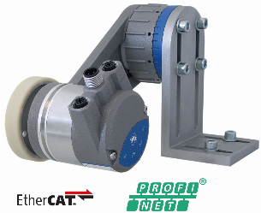
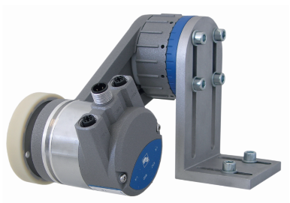
Images:

WA1904_Wachendorff_LMSMA.jp WA1904_Wachendorff_LMSMA_logo.jpg

