Contact person for editorial offices:
Dirk Rott, Head of Marketing

08.06.2018/ DRO
Press release WA1803: Most compact EtherCAT encoder
Images/text are approved for publication in the trade press (print and online). Please send us a specimen copy after publication. Thank you for your efforts in advance.
________________________________________________________________________
Most compact EtherCAT encoder in the world
Highly accurate and highly dynamic
Faster, more accurate and more compact

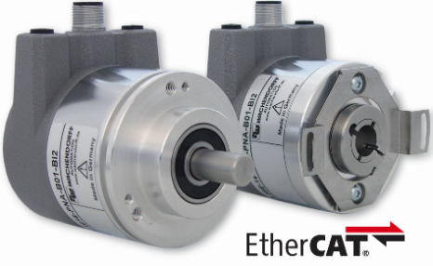
Wachendorff Automation has extended its absolute encoder series WDGA with the interfaces SSI, CAN, Profibus, by another Industrial Ethernet interface - besides ProfiNet - by the EtherCAT protocol.
Wachendorff can also offer the world's smallest encoder with bus cover in the EtherCAT interface with the WDGA58F design.
This saves valuable installation space and can therefore be decisive in new or advanced machines, as the trend towards more compact machines continues unabated. Despite this unique compactness, the high bearing loads guarantee a long service life and maximum durability.
The EtherCAT encoders from Wachendorff can be ordered as hollow shaft and clamp/synchro flange versions.
In the multiturn area, the EtherCAT encoders are equipped with maintenance-free and space-saving EnDra® technology. The innovative singleturn range with QuattroMag® technology provides a high resolution of up to 16 bits and an accuracy of +/- 0.0878° (12 bits).
This makes it possible to use robust and durable magnetic technology from Wachendorff in many areas where previously only high-precision and sensitive optical measuring technology could be used.
The new EtherCAT absolute value encoders with SM3 mode, distributed clock and Can over EtherCAT (DS 406 compatible) can deliver their high-precision position value with a cycle time of up to 50µs and are thus perfectly equipped for the latest controllers in the field. Plant and machine builders also benefit from the modular principle used by Wachendorff Automation for the design of customer variants, which can thus be implemented very quickly and cost-effectively.

