Contact:
Dirk Rott, Marketing Director

July 18, 2017 / DRO
Press Release WA1701: Wachendorff Automation awarded 2017 Innovator of the Year
Photos/text are released for publication to specialised publications (print and online). Please send us a specimen copy after publication. Thank you in advance.
________________________________________________________________________
Wachendorff Automation is awarded "2017 Innovator of the Year"
Wachendorff Automation is one of Germany’s most innovative companies

Wachendorff Automation GmbH & Co. KG, located in Geisenheim/Rheingau, provider of innovative sensor technology (incremental and absolute encoders) and measuring systems for mechanical / plant engineering and renewable energy applications, is thrilled about this recent award. Wachendorff Automation was selected by the business magazine brand eins Wissen and Statista, the online statistics portal, as “2017 Innovator of the Year” in the category “Automation and Measurement Technology, small and medium-sized businesses with up to 250 employees” for its products and services. Once again, Wachendorff can count itself as one of Germany’s top innovators.

This award acknowledges the innovative abilities, unconditional quest for quality, productivity and creativity of this family-owned, medium-sized company and its highly motivated employees.

For the ranking, about 2,000 company representatives, 250 experts from the Berlin Institute for Innovation and Technology (IIT), and 20,000 managers and employees with many years’ of experience in the field were surveyed.

“We are so happy! This award confirms that our EnDra® and QuattroMag® technology, which we have integrated into our sensor technology (absolute encoders), represents significant monetary value for our users and this will open up new business opportunities for us”, said Robert Wachendorff, Managing Partner for Wachendorff Automation. “As a medium-sized company, it is absolutely fantastic and highly motivating to be held in such high esteem by others”.

Wachendorff Automation’s website: www.wachendorff-automation.de
More on this topic: https://kiosk.brandeins.de/products/innovation-2017-brand-eins-thema
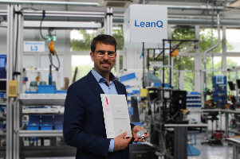
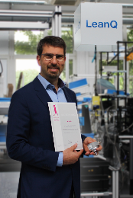
Images (Wachendorff Automation):
WA1701_PI_Brand_eins_Statista_Innovator_2017_Robert_Wachendorff_hoch_print.jpg
WA1701_PI_Brand_eins_Statista_Innovator_2017_Robert_Wachendorff_quer_print.jpg

